# Mobile App

Interface Design

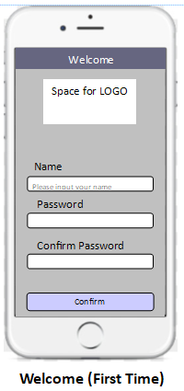

The initial screen which is shown on the first launch of the app, where the user is prompted to input their name and a password.

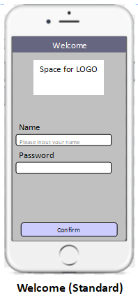

When the app is opened after this first launch, the second login screen will be displayed.

The settings page, which will contain important options. For example the ability for a user to change their name and password, export their budget data to a .csv file format, or reset their budget data.

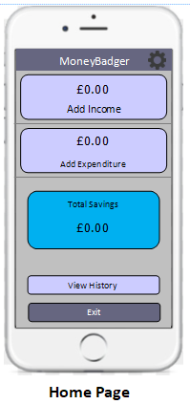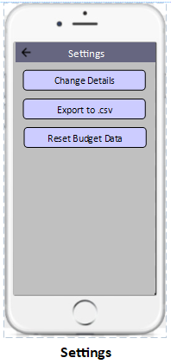

This is the main menu, where most essential features can be accessed. Buttons navigate to the Add Income, Add Expenditure and Budget History pages, while showing the user’s total savings and allowing exit from the app.

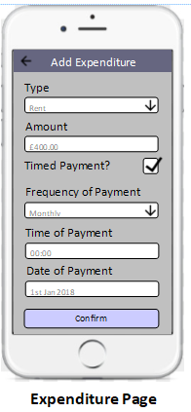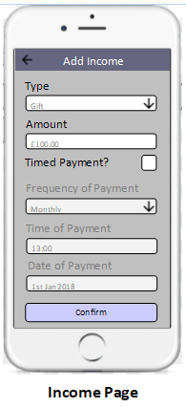

The Add Income page, with data input field such as drop down boxes, tick boxes and text boxes to allow the user to enter the details of an input of money.

Similar the Income page, the Add Expenditure page allows the user to outline an output of money.

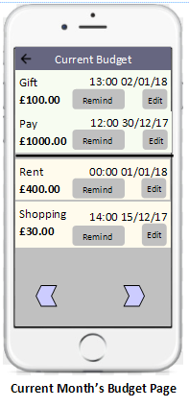

Clicking the ‘View History’ Button navigates to the History page, which shows initially the user’s budget information for the current month. This includes the payment type, amount and time of input. Each income and expenditure has an entry in the corresponding list on the page, with options to add a timed reminder, or edit the information of the budget entry. Arrows allow the user to navigate to the budgeting information of previous or future months.

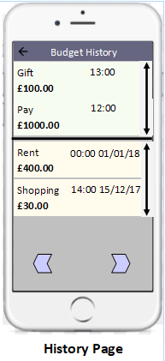

Similar to the current month’s budget viewer, the budget information of past months can also be viewed.

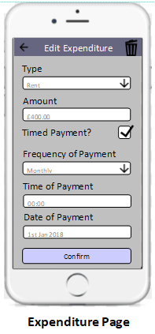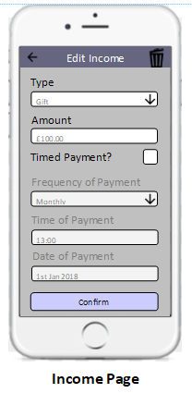

If the user needs to edit or delete an entry, a page similar to the Add Income/Expenditure page is displayed.

The user can set reminders for an input or output in the budget, which can be added with the Set Reminder page. This allows the input of relevant information to display a timed alert.

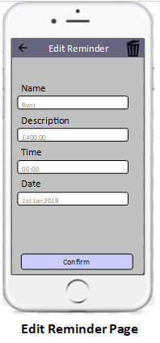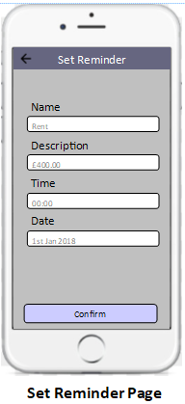

This alert can also be edited.